

**Patient Registration Form** **Page 1**



|  |  |  |  |  |  |  |  |  |  |  |  |  |  |  |  |  |  |  |  |  |  |  |  |  |  |  |  |  |  |  |  |  |  |
| --- | --- | --- | --- | --- | --- | --- | --- | --- | --- | --- | --- | --- | --- | --- | --- | --- | --- | --- | --- | --- | --- | --- | --- | --- | --- | --- | --- | --- | --- | --- | --- | --- | --- |
|  |  |  |  |  |  |  |  |  |  |  |  |  |  |  |  |  |  |  |  |  |  |  |  |  |  |  |  |  |  |  |  |  |  |
| Date of Registration | | | | | | | | | |  |  |  |  |  |  |  |  |  |  |  |  |  |  |  |  |  |  |  |  |  |  |  |  |
| Last Name | | | | |  |  |  |  |  |  |  |  |  |  |  | First Name | | | | | |  |  |  |  |  |  |  |  |  |  |  |  |
| Middle Name | | | | | |  |  |  |  |  |  |  |  |  |  |  |  |  |  |  |  |  | Suffix | | |  | | |  | | | | |
| Sex: M | | | | | | | F |  |  |  |  |  | Previous Last Name | | | | | | |  |  |  |  |  |  |  |  |  |  |  |  | |  |
| Date of Birth (M/D/Y) | | | | | | | | | | | |  |  |  |  |  |  |  | Social Security # | | | | | |  |  |  |  |  | |  | |  |
|  |  |  |  |  |  |  |  |  |  |  |  | |
| Home Address | | | | | | |  |  |  |  |  |  |  |  |  |  |  |  |  |  |  |  |  |  |  |  |  |  |  |  |  |  |  |
| Home Address Cont. | | | | | | | | | | |  | |  |  |  |  |  |  |  |  |  |  |  |  |  |  |  |  |  |  |  |  |  |
| Zip |  |  |  |  | | |  |  |  | City | | | |  |  |  |  |  |  |  |  |  |  | State | | |  |  |  | | | |  |
| Country | | |  |  | | |  |  |  |  |  |  |  |  |  |  |  |  |  |  |  |  |  |  |  |  |  |  |  |  |  |  |  |
| Phone # | | | |  | | |  |  |  |  |  |  |  |  |  |  |  | Work# | | |  | | | | | | | | | | | | |
| Cell # | |  |  |  |  |  |  |  |  |  |  |  |  |  |  |  |  |  |  |  |  |  |  |  |  |  |  |  |  |  |  |  |  |
| No Email: | | | | | | |  | Email | | | | |  | |  |  |  |  |  |  |  |  |  |  |  |  |  |  |  |  |  |  |  |

Contact Preference Language:

Race:  Caucasion  African American  Other

Ethnicity:  Hispanic  Non-Hispanic

|  |  |  |  |  |  |  |  |  |  |  |  |  |  |  |  |  |  |  |  |  |  |  |  |  |  |
| --- | --- | --- | --- | --- | --- | --- | --- | --- | --- | --- | --- | --- | --- | --- | --- | --- | --- | --- | --- | --- | --- | --- | --- | --- | --- |
| Marital Status | | | Single | | | | | | | | Married | | | | Divorced | | | | Separated | | | |  |  |  |
| Homebound: | | | No | | | | Yes | | | |  |  |  |  |  |  |  |  |  |  |  |  |  |  |  |
| How did you hear about us? | | | | | | | | | | |  |  |  |  |  |  |  |  |  |  |  |  |  |  |  |
| Guardian Last Name | | | | | |  |  |  |  |  |  |  |  |  |  | Guardian First Name | | | | | |  |  |  |  |
| Guardian Middle Name | | | | | | |  |  |  |  |  |  |  |  |  |  |  |  | Suffix |  | | |  |  |  |
| Emergency Contact Name | | | | | | | | |  |  |  |  |  |  |  |  |  |  |  |  |  |  |  |  |  |
|  |  |  |  |  |  |  |  |  |  |  |  |  |  |  |  |  |
| Emergency Contact Relation | | | | | | | | | | |  |  |  |  |  |  |  |  |  |  |  |  |  |  |  |
|  |  |  |  |  |  |  | Mobile Phone | | | | |  |  |  |
| Emergency Contact Phone | | | | | | | | | |  |  |  |  |  |  |  |  |  |  |  |
|  |  |  |  |  |  |  |  |  |  |  |
| Next of Kin Name | | | |  |  | |  |  |  |  |  |  |  |  |  | Next of Kin Relation | | | | |  | |  |  |  |
| Next of Kin Phone | | | | |  | |  |  |  |  |  |  |  |  |  |  |  |  |  |  |  |  |  |  |  |
| I give permission to share medical information with: | | | | | | | | | | | | | | | | | | | No One | | | | Guardian |  |  |
| Next of Kin | | | Emergency Contact | | | | | | | | | | | |  | Guarantor | | |  |  |  |  |  |  |  |
| Other | |  |  |  |  |  |  |  |  |  |  |  |  |  |  |  |  |  |  |  |  |  |  |  |  |
| I give permission to share financial information with: | | | | | | | | | | | | | | | | | | | No One | | | | Guardian |  |  |
| Next of Kin | | | Emergency Contact | | | | | | | | | | | |  | Guarantor | | |  |  |  |  |  |  |  |
| Other |  | |  |  |  |  |  |  |  |  |  |  |  |  |  |  |  |  |  |  |  |  |  |  |  |
|  | |  |  |  |  |  |  |  |  |  |  |  |  |  |  |  |  |  |  |  |  |  |  |  |
| Permission to leave message on answering machine / voice mail: | | | | | | | | | | | | | | | | | | | | | | | Yes | No | |
| **Guarantor Information** (name to whom statements are sent) | | | | | | | | | | | | | | | | | | | | | | | Same |  |  |
| Patient’s Relationship to Guarantor | | | | | | | | | | | | | |  |  |  |  |  |  |  |  |  |  |  |  |
|  |  |  |  |  |  |  |  |  |  |  |  |

|  |  |  |  |  |  |  |  |  |  |  |  |  |  |  |  |  |  |  |  |  |  |  |  |  |  |  |  |  |  |  |  |  |  |  |  |  |  |  |  |  |  |  |
| --- | --- | --- | --- | --- | --- | --- | --- | --- | --- | --- | --- | --- | --- | --- | --- | --- | --- | --- | --- | --- | --- | --- | --- | --- | --- | --- | --- | --- | --- | --- | --- | --- | --- | --- | --- | --- | --- | --- | --- | --- | --- | --- |
|  |  |  |  |  |  |  |  |  |  |  |  |  |  |  |  |  |  |  |  |  |  |  |  |  |  |  |  |  |  |  |  |  |  |  |  |  |  |  |  |  |  |  |
| Guarantor Last Name | | | | | | | | | | | |  |  |  |  |  |  |  |  |  |  |  |  |  |  |  |  |  |  |  |  |  |  |  |  |  |  |  |  |  |  |  |
| Guarantor First Name | | | | | | | | | | | |  |  |  |  |  |  |  |  |  |  |  |  |  |  |  |  |  |  |  |  |  |  |  |  |  |  |  |  |  |  |  |
|  |  |  |  |  |  |  |  |  |  |  |  |  |  |  |  |  |  |  |  |  |  |  |  |  |  |  |  |  |  |  |
| Guarantor Middle Name | | | | | | | | | | | | | | | | | |  |  |  |  |  |  |  |  |  |  |  |  |  | Suffix | | | | |  |  |  |  |  |  |  |
| Guarantor Date of Birth (M/D/Y) | | | | | | | | | | | | | | | | | | | | | | |  |  |  |  |  |  |  |  | |  |  |  |  |  |  |  |  |  |  |  |
| Guarantor mailing address same as patient’s address? | | | | | | | | | | | | | | | | | | | | | | | | | | | | | | | | | Yes | | | | | | | No | | |
| Guarantor Address | | | | | | | | | | |  |  |  |  |  |  |  |  |  |  |  |  |  |  |  |  |  |  |  |  |  |  |  |  |  |  |  |  |  |  |  |  |
| Guarantor Zip | | | | | | | | |  |  | |  |  |  |  |  |  |  |  |  | City | | |  |  |  |  |  |  |  | |  |  |  | State | | | | |  |  |  |
| Country | | | |  |  |  |  |  | |  | |  |  |  |  |  |  |  |  |  |  |  |  |  |  |  |  |  |  |  |  |  |  |  |  |  |  |  |  |  |  |  |
| **Patient Mailing Address** | | | | | | | | | | | | | | | | | | | | |  |  | **Same** | | | | | | | | | |  |  |  |  |  |  |  |  |  |  |
| Mailing Address | | | | | | | | | |  | |  |  |  |  |  |  |  |  |  |  |  |  |  |  |  |  |  |  |  |  |  |  |  |  |  |  |  |  |  |  |  |
|  | |  |  |  |  |  |  |  |  |  |  |  |  |  |  |  |  |  |  |  |  |  |  |  |  |  |  |  |  |  |  |  |
| Mailing Zip | | | | | | |  |  | | | |  |  |  |  |  | City | | | |  |  |  |  |  |  |  |  |  |  |  |  | State | | | |  |  |  |  |  |  |
| Alternate Phones | | | | | | | | | | | | None | | | | | | | | |  | Home # | | | |  |  |  |  |  | | |  |  |  |  |  |  |  |  |  |  |
| Work # | | |  | |  |  | |  | | | |  |  |  |  |  |  |  |  |  |  |  |  |  |  |  | Cell # | |  |  | | |  |  |  |  |  |  |  |  |  |  |
| Spouse Name | | | | | | | |  | | | |  |  |  |  |  |  |  |  |  |  |  |  |  |  |  |  |  |  |  |  |  |  |  |  |  |  |  |  |  |  |  |
| Spouse Date of Birth | | | | | | | | | | | |  |  |  |  |  |  |  |  |  |  |  |  |  |  |  |  | Social Security # | | | | | | | | | | |  |  |  |  |
| **Parents** | | | | | | | | | | | |  |  |  |  |  |  |  |  |  |  |  |  |  |  |  |  |  |  |  |  |  |  |  |  |  |  |  |  |  |  |  |
| Mother’s information | | | | | | | | | | | |  |  |  |  |  |  | Default patient info | | | | | | | | | | | | | | |  |  |  |  |  |  |  |  |  |  |
| Name | |  | | |  |  | | | | | |  |  |  |  |  |  |  |  |  |  |  |  |  |  |  |  |  |  |  |  |  |  |  |  |  |  |  |  |  |  |  |
| Address | | | | | |  | | | | | |  |  |  |  |  |  |  |  |  |  |  |  |  |  |  |  |  |  |  |  |  |  |  |  |  |  |  |  |  |  |  |
| Zip |  | | | |  | | | | | | |  |  |  |  |  | City | | | |  |  |  |  |  |  |  |  |  |  |  |  | State | | | | |  | |  |  |  |
| Country | | | | |  | | | | | | |  |  |  |  |  |  |  |  |  |  |  |  |  |  |  |  |  |  |  |  |  |  |  |  |  |  |  |  |  |  |  |
| Father’s information | | | | | | | | | | | |  |  |  |  |  | Default patient info | | | | | | | | | | | | | | | |  |  |  |  |  |  |  |  |  |  |
| Name | |  | | | | | | | | | |  |  |  |  |  |  |  |  |  |  |  |  |  |  |  |  |  |  |  |  |  |  |  |  |  |  |  |  |  |  |  |
| Address | | | | | |  | | | | | |  |  |  |  |  |  |  |  |  |  |  |  |  |  |  |  |  |  |  |  |  |  |  |  |  |  |  |  |  |  |  |
| Zip |  | | | | | | | | | | |  |  |  | City | | | |  | |  |  |  |  |  |  |  |  |  |  | State | | | |  | | | | |  |  |  |
| Country | | | | |  | | | | | | |  |  |  |  |  |  |  |  |  |  |  |  |  |  |  |  |  |  |  |  |  |  |  |  |  |  |  |  |  |  |  |

**Employment** (e.g., full-time, part-time, self-employed, retired, etc.)

|  |  |  |  |  |  |  |  |  |  |  |  |  |
| --- | --- | --- | --- | --- | --- | --- | --- | --- | --- | --- | --- | --- |
| Employer | | |  |  |  |  | Occupation | | | |  |  |
| Address | |  | |  |  |  |  |  |  |  |  |  |
| Zip |  | | |  | City |  |  | State | |  | |  |
| Employer Phone | | | |  |  |  |  |  |  |  |  |  |

**Insurance**

I do not have insurance and will be responsible for payment



**Patient Registration Form** **Page 2**

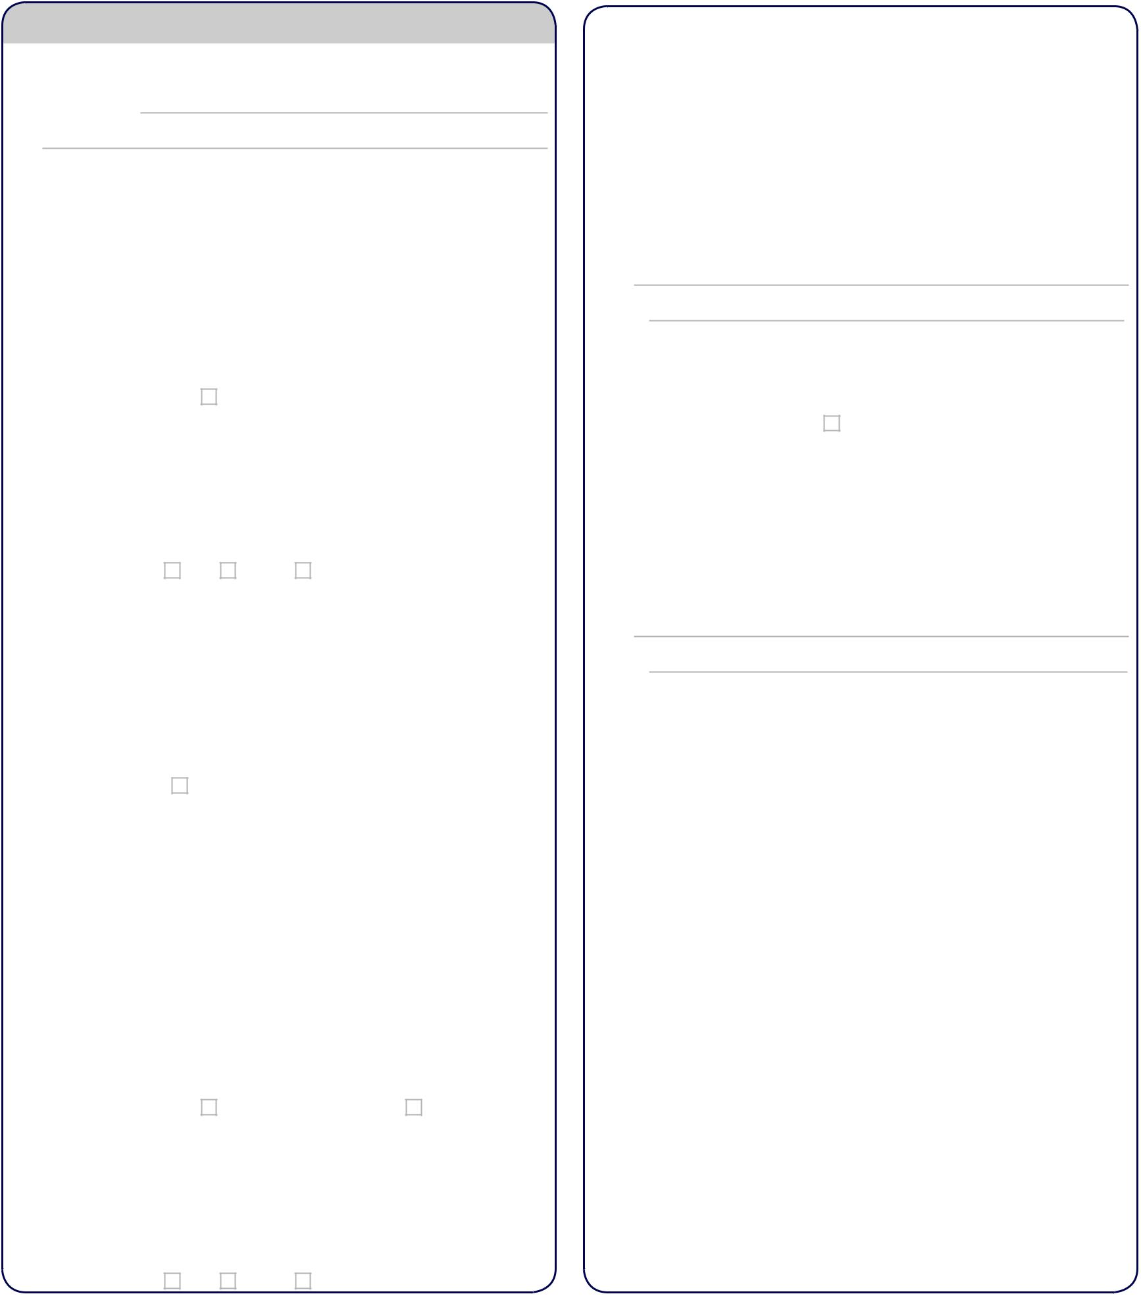

**Primary Insurance**

Insurance company

Type

|  |  |  |  |  |  |  |  |  |  |  |  |  |  |  |  |  |  |  |  |  |  |  |  |  |  |  |  |  |  |  |  |  |  |  |  |  |  |  |  |  |  |  |  |  |  |  |  |  |  |  |  |  |  |  |
| --- | --- | --- | --- | --- | --- | --- | --- | --- | --- | --- | --- | --- | --- | --- | --- | --- | --- | --- | --- | --- | --- | --- | --- | --- | --- | --- | --- | --- | --- | --- | --- | --- | --- | --- | --- | --- | --- | --- | --- | --- | --- | --- | --- | --- | --- | --- | --- | --- | --- | --- | --- | --- | --- | --- |
| Address | | | | | |  |  |  |  |  |  |  |  |  |  |  |  |  |  |  |  |  |  |  |  |  |  |  |  |  |  |  |  |  |  |  |  |  |  |  |  |  |  |  |  |  |  |  |  |  |  |  |  |  |
| Zip |  |  |  |  |  | |  |  |  |  |  |  |  |  |  |  |  |  |  |  | City | | | | | |  |  |  |  |  |  |  |  |  |  |  |  |  |  |  |  |  |  |  |  |  |  | State | | | | |  |
| Phone | | | |  |  | |  |  |  |  |  |  |  |  |  |  |  |  |  |  |  |  |  |  |  |  |  |  |  |  |  | Fax | |  |  |  |  |  |  |  |  |  |  |  |  |  |  |  |  |  |  |  |  |  |
| Policy Information | | | | | | | | | | | | | | | | | | | | | | | | | | | |  |  |  |  |  |  |  |  |  |  |  |  |  |  |  |  |  |  |  |  |  |  |  |  |  |  |  |
| Policy # | | | | |  | |  |  |  |  |  |  |  |  |  |  |  |  |  |  |  |  |  |  |  |  |  |  |  |  |  |  |  | Effective date | | | | | | |  |  |  |  |  |  |  |  | |  |  |  |  |  |
| Group # | | | | | | |  |  |  |  |  |  |  |  |  |  |  |  |  |  |  |  |  |  |  |  |  |  |  |  | Expiration date | | | | | | |  |  |  | |  |  |  |  |  |  |  | |  |  |  |  |  |
| **Policy holder information** | | | | | | | | | | | | | | | | | | | | | | | | | | | | | Same as patient information | | | | | | | | | | | | | | | | | | | | | | |  |  |  |
| Last Name | | | | | | | | | |  |  |  |  |  |  |  |  |  |  |  |  |  |  |  |  |  |  |  |  |  |  |  |  |  |  |  |  |  |  |  |  |  |  |  |  |  |  |  |  |  |  |  |  |  |
|  |  |  |  |  |  |  |  |  |  |  |  |  |  |  |  |  |  |  |  |  |  |  |  |  |  |  |  |  |  |  |  |  |  |  |  |  |  |  |  |  |  |  |  |  |
| First Name | | | | | | | | | | |  |  |  |  |  |  |  |  |  |  |  |  |  |  |  |  |  |  |  |  |  |  |  |  | Middle Name | | | | | | | | | |  |  |  |  | |  |  |  |  |  |
| Address | | | | | | | |  |  | | |  |  |  |  |  |  |  |  |  |  |  |  |  |  |  |  |  |  |  |  |  |  |  |  |  |  |  |  |  |  |  |  |  |  |  |  |  |  |  |  |  |  |  |
| Zip |  |  |  | | | | | |  | | |  |  |  |  |  |  | City | | | | | |  |  |  | |  |  |  |  |  |  |  |  |  |  |  |  |  |  |  |  |  |  |  |  | State | | | |  |  |  |
| Relationship to patient: | | | | | | | | | | | | | | | | | | | | | | | | | | | | Self |  |  | Spouse | | | |  |  | Other | | | | |  |  |  | | |  |  | |  |  |  |  |  |
| Date of Birth | | | | | | | | | | | | |  |  |  |  |  |  |  |  |  |  |  |  |  |  |  |  |  |  | Social Security # | | | | | | | | |  | | |  |  | | |  |  | |  |  |  |  |  |
| Policyholder Phone | | | | | | | | | | | | | | | | | | |  | |  |  |  | |  |  | |  |  |  |  |  |  |  |  |  |  |  |  |  |  |  |  |  |  |  |  |  |  |  |  |  |  |  |
| Employer | | | | | | | | |  | | |  |  |  |  |  |  |  |  |  |  |  |  |  |  |  |  |  |  |  |  |  |  |  |  |  | Employer Phone | | | | | | | | | | | | | |  |  |  |  |
| Employer Address | | | | | | | | | | | | | | | | |  |  | | |  |  |  | |  |  | |  |  |  |  |  |  |  |  |  |  |  |  |  |  |  |  |  |  |  |  |  |  |  |  |  |  |  |
| Zip | |  |  | | | | | | | | |  |  |  |  |  |  |  |  |  |  | City | | | | | |  |  |  |  |  |  |  |  |  |  |  |  | State | | | |  | | |  |  | |  | |  |  |  |
| **Secondary Insurance** | | | | | | | | | | | | | | | | | | | | | | | | | | | | None | | | | | | |  |  |  |  |  |  |  |  |  |  |  |  |  |  |  |  |  |  |  |  |
| Insurance company | | | | | | | | | | | | | | | | | | | | |  | |  | |  |  | |  |  |  |  |  |  |  |  |  |  |  |  |  |  |  |  |  |  |  |  |  |  |  |  |  |  |  |
|  | |  | |  |  | |  |  |  |  |  |  |  |  |  |  |  |  |  |  |  |  |  |  |  |  |  |  |  |  |  |  |  |
| Type | | |  | | | | | | | | |  |  |  |  |  |  |  |  |  |  |  |  |  |  |  |  |  |  |  |  |  |  |  |  |  |  |  |  |  |  |  |  |  |  |  |  |  |  |  |  |  |  |  |
| Address | | | | | |  | | | | | |  |  |  |  |  |  |  |  |  |  |  |  |  |  |  |  |  |  |  |  |  |  |  |  |  |  |  |  |  |  |  |  |  |  |  |  |  |  |  |  |  |  |  |
| Zip |  | | | | | | | | | | |  |  |  |  |  |  |  |  |  | City | | | | |  | |  |  |  |  |  |  |  |  |  |  |  |  |  |  |  |  |  |  |  |  |  | State | | | |  | |
| Phone | | | |  | | | | | | | |  |  |  |  |  |  |  |  |  |  |  |  |  |  |  |  |  |  |  |  | Fax | |  |  |  |  |  |  |  |  |  |  |  |  |  |  |  |  |  |  |  |  |  |
| Policy Information | | | | | | | | | | | | | | | | | | | | | | | | | | | |  |  |  |  |  |  |  |  |  |  |  |  |  |  |  |  |  |  |  |  |  |  |  |  |  |  |  |
| Policy # | | | | |  | | | | | | |  |  |  |  |  |  |  |  |  |  |  |  |  |  |  |  |  |  |  |  |  |  | Effective date | | | | | | |  | |  | | | | |  | |  | |  |  |  |
| Group # | | | | | | |  | | | | |  |  |  |  |  |  |  |  |  |  |  |  |  |  |  |  |  |  |  | Expiration date | | | | | | |  | | | | |  | | | | |  | |  | |  |  |  |
| **Policy holder information** | | | | | | | | | | | | | | | | | | | | | | | | | | | | | Same as patient information | | | | | | | | | | | | | | | | | | | | | | | Same as primary | | |
| ins. holder | | | | | | | | | | | | | Last Name | | | | | | | | | | | |  | | |  |  |  |  |  |  |  |  |  |  |  |  |  |  |  |  |  |  |  |  |  |  |  |  |  |  |  |
|  | | |  |  |  |  |  |  |  |  | Middle Name | | | | | | | | | | | |  |  |  |  |  |  |  |
| First Name | | | | | | | | | | | |  |  |  |  |  |  |  |  |  |  |  |  |  |  |  |  |  |  |  |  |  |  |  |  |  | |  | |  |  |  |
|  |  |  |  |  |  |  |  |  |  |  |  |  |  |  |  |  |  |  |  |  |  |  |  |  | |  | |  |  |  |
| Address | | | | | | | |  | | | | |  |  |  |  |  |  |  |  |  |  |  |  |  |  |  |  |  |  |  |  |  |  |  |  |  |  |  |  |  |  |  |  |  |  |  |  |  |  |  |  |  |  |
| Zip |  | | | | | | | | | | | |  |  | City | | | | | | | |  | | | | |  |  |  |  |  |  |  |  |  |  |  |  |  |  |  |  |  | State | | | | |  | |  |  |  |
| Relationship to patient: | | | | | | | | | | | | | | | | | | | | | | | | | | | | Self |  |  | Spouse | | | |  |  | Other | | | | |  | | | | | | | | | |  |  |  |

|  |  |  |  |  |  |  |  |  |  |  |  |  |  |  |  |  |
| --- | --- | --- | --- | --- | --- | --- | --- | --- | --- | --- | --- | --- | --- | --- | --- | --- |
|  |  |  |  |  |  |  |  |  |  |  |  |  |  |  |  |  |
| Date of Birth | | |  |  |  |  |  | Social Security # | |  |  |  |  |  |  |  |
| Policyholder Phone | | | | |  |  |  |  |  |  |  |  |  |  |  |  |
| Employer | |  | |  |  |  |  |  | Employer Phone | | | |  |  |  | |
| Employer Address | | | |  |  |  |  |  |  |  |  |  |  |  |  |  |
| Zip |  | | | |  | City |  |  |  |  | State |  | |  | | |

**Primary Healthcare Provider**

Name

Address

|  |  |  |  |  |  |  |  |  |  |  |  |  |  |  |  |  |  |  |
| --- | --- | --- | --- | --- | --- | --- | --- | --- | --- | --- | --- | --- | --- | --- | --- | --- | --- | --- |
| Zip |  |  |  |  |  | City | |  |  |  |  |  |  |  | State | |  |  |
| Office Phone | | | |  |  |  |  |  |  |  | Office Fax | |  |  | |  | |  |
| **Referring Healthcare Provider** | | | | | | | | | Same as Primary Healthcare Provider | | | | | | | | | |
| Name | |  |  | |  |  |  |  |  |  |  |  |  |  |  |  |  |  |
|  |  | |  |  |  |  |  |  |  |  |  |  |  |  |  |  |
| Address | | |  | |  |  |  |  |  |  |  |  |  |  |  |  |  |  |
| Zip |  | | | |  | City |  | |  |  |  |  |  |  | State |  | | |
| Office Phone | | | |  | |  |  |  |  | Office Fax | |  | | | | | | |

**Treating Healthcare Specialist** e.g., cardiologist, gastroenterologist, oncologist

Name

Address

|  |  |  |  |  |  |  |  |  |  |
| --- | --- | --- | --- | --- | --- | --- | --- | --- | --- |
| Zip |  |  | City |  |  |  | State |  |  |
| Office Phone | |  |  |  | Office Fax |  | |  |  |

**Primary Pharmacy**

|  |  |  |  |  |  |  |  |  |  |  |  |  |
| --- | --- | --- | --- | --- | --- | --- | --- | --- | --- | --- | --- | --- |
| Name | |  |  |  |  |  |  |  |  |  |  |  |
|  |  |  |  |  |  |  |  |  |  |  |
| Address | | | |  |  |  |  |  |  |  |  |  |
| Zip |  | |  |  | City |  |  |  | State |  | |  |
| Phone | | |  |  |  |  | Fax |  | | | |  |

**Secondary Pharmacy**

|  |  |  |  |  |  |  |  |  |  |  |  |  |
| --- | --- | --- | --- | --- | --- | --- | --- | --- | --- | --- | --- | --- |
| Name | |  |  |  |  |  |  |  |  |  |  |  |
|  |  |  |  |  |  |  |  |  |  |  |
| Address | | | |  |  |  |  |  |  |  |  |  |
| Zip |  | |  |  | City |  |  |  | State |  | |  |
| Phone | | |  |  |  |  | Fax |  | | | |  |

**Other Pharmacy**

|  |  |  |  |  |  |  |  |  |  |  |  |  |  |
| --- | --- | --- | --- | --- | --- | --- | --- | --- | --- | --- | --- | --- | --- |
| Name | |  |  |  |  |  |  |  |  |  |  |  |  |
|  |  |  |  |  |  |  |  |  |  |  |  |
| Address | | | |  |  |  |  |  |  |  |  |  |  |
| Zip |  | |  |  | City |  |  |  | State |  |  | |  |
| Phone | | |  |  |  |  | Fax |  | | | | |  |



**Patient Registration Form** **Page 3**

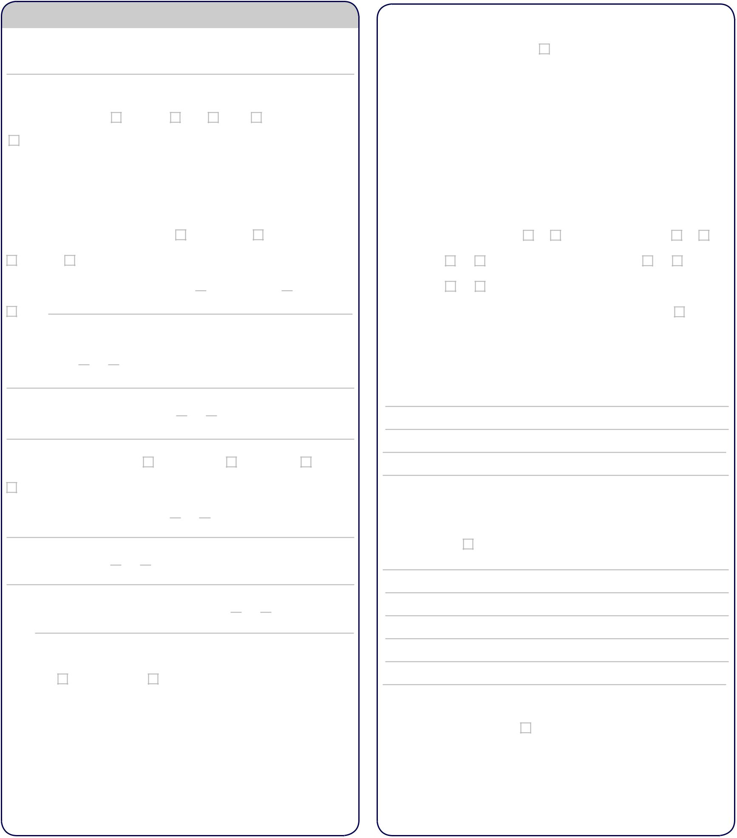

**Chief Complaint:** What is the main reason for your visit today?

**History of Present Illness**

|  |  |  |  |  |  |  |  |  |
| --- | --- | --- | --- | --- | --- | --- | --- | --- |
| Location of the problem: | | | | Abdomen | | Back | Groin | Bladder |
| Other |  |  |  |  |  |  |  |  |
| On a scale of 1-10, with 10 being the most severe, | | | | | | |  |  |
| What number best describes the problem? | | | | | |  |  |  |
| When did you first notice the problem? | | | | |  |  |  |  |
| Does anything make the problem worse? | | | | | | Moving About | | Standing Up |
| Urinating | | Other |  |  |  |  |  |  |

Does anything help make the problem better?  Change Posture  Not Moving

Other

Are there any treatments that your doctor would provide that are prohibited by your religious beliefs?  No  Yes If Yes, Please explain.

|  |  |  |  |  |  |  |
| --- | --- | --- | --- | --- | --- | --- |
|  |  |  |  |  |  |  |
|  | **Surgery History:** Type / Date | | | None | | |
|  |  |  |  |  |  |  |
|  |  |  |  |  |  |  |
|  |  |  |  |  |  |  |
|  |  |  |  |  |  |  |
|  |  |  |  |  |  |  |
|  |  |  |  |  |  |  |
|  |  |  |  |  |  |  |

|  |  |  |  |  |  |  |  |
| --- | --- | --- | --- | --- | --- | --- | --- |
| Have you had a blood transfusion? No Yes Artificial heart valve? | | | | | | | No Yes |
| Artificial joint? | | No | Yes | Antibiotic prophylaxis required? | | No | Yes |
| Cardiac stent? | | No | Yes | Date |  |  |  |
| **Medical History:** List any past or current illness and start date: | | | | | |  | None |
|  |  |  |  |  |  |  |  |
|  |  |  |  |  |  |  |  |
|  |  |  |  |  |  |  |  |

Have the symptoms changed over time?  No  Yes If Yes, Please explain.

|  |  |  |  |  |  |  |
| --- | --- | --- | --- | --- | --- | --- |
| How long does the problem last? | |  | Minutes |  | Hours | Constant |
| Other |  |  |  |  |  |  |

Is anything occurring at the same time?  No  Yes If Yes, Please explain.

Is the problem constant?  No  Yes If not, please describe.

Does the problem interfere with your normal function?  No  Yes If Yes, Please explain

**Past Medical, Social History, Family History**

|  |  |  |  |
| --- | --- | --- | --- |
| Allergies: | No drug allergies | Latex |  |
|  |  |  |  |
|  |  |  |  |
|  |  |  |  |
|  |  |  |  |
|  |  |  |  |
|  |  |  |  |
|  |  |  |  |

**Family History:** Condition, relationship (list any serious conditions in your imme-diate family: e.g., diabetes, heart disease, kidney disease, kidney stones, prostate

|  |  |
| --- | --- |
| cancer, etc.): | None |

**Medications/herbs/supplements:** name, dosage, instructions —

|  |  |  |
| --- | --- | --- |
| (e.g., Flomax 0.4mg once daily) | | None |
|  |  |  |
|  |  |  |
|  |  |  |
|  |  |  |



|  |  |  |  |  |  |  |  |  |
| --- | --- | --- | --- | --- | --- | --- | --- | --- |
|  |  | **Patient Registration Form** | | | | | **Page 4** | |
|  |  |  |  |  |  |  |  |  |
|  |  |  |  |  |  |  |  |  |
| **Medications/herbs/supplements (continued):** | |  |  |  |  | Any: Hearing Loss, Stuffy Nose, or Sore Throat?No | Yes | |
|  |  |  |  |  |  |
|  |  |  |  |  |  |  |  |  |
|  |  |  |  |  |  |  |  |  |
|  |  |  |  |  |  | Any: Chest Pain, Swollen Ankles, or Irregular Heart Beats? | NoYes | |
|  |  |  |  |
|  |  |  |  |  |  |  |  |  |
|  |  |  |  |  |  |  |  |  |
|  |  |  |  |  |  |  |  |  |

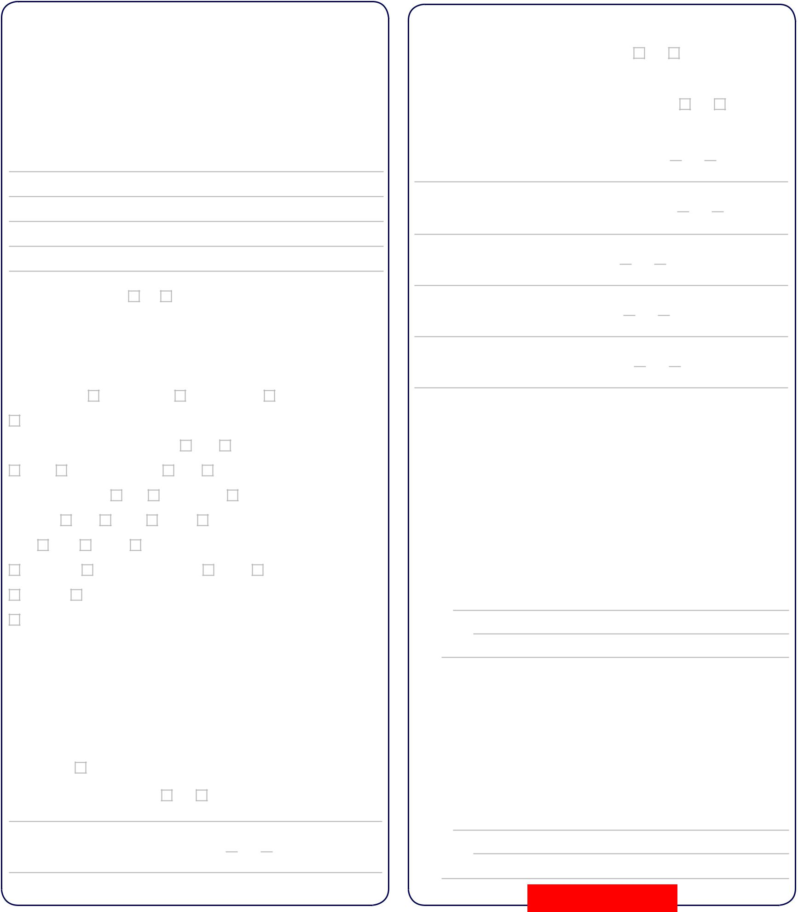

|  |  |  |  |  |  |  |  |  |  |  |  |  |  |  |  |  |  |  |  |  |  |  |  |  |  |  |  |  |  |  |  |  |  |  |
| --- | --- | --- | --- | --- | --- | --- | --- | --- | --- | --- | --- | --- | --- | --- | --- | --- | --- | --- | --- | --- | --- | --- | --- | --- | --- | --- | --- | --- | --- | --- | --- | --- | --- | --- |
| Are you on a special diet? | | | | | | | | | | | No | | | | |  | Yes | | | | If yes, please explain. | | | | | | | | | | |  |  |  |
|  |  | | |  |  | |  | |  |  | |  |  |  |  |  |  |  |  |  |  |  |  |  |  |  |  |  |  |  |  |  |  |  |
| Date of last physical examination | | | | | | | | | | | | | | |  |  |  |  |  |  |  |  |  |  |  |  |  |  |  |  |  |  |  |  |
| **What is your Height?** | | | | | | | | | |  |  | ft. | | | |  |  |  |  |  | in. **What is your Weight?** | | | | | | | | | |  |  |  | lbs. |
| Smoking History | | | | | |  |  | Never Smoked | | | | | | | | | Former Smoker | | | | | | | | | | |  | Current Smoker | | | | | |
| Current Some Day Smoker | | | | | | | | | | | | | | | |  | Started Smoking | | | | | | | | |  |  |  |  |  |  |  |  |  |
| Stopped Smoking | | | | | |  |  |  |  |  |  |  |  | Amt: | | | | | | | Day | | Week | | | | |  |  |  |  |  |  |  |
| Chew | |  | Dip tobacco | | | | | | | | Amt: | | | | |  | Day | | | | Week | | | |  | |  |  |  |  |  |  |  |  |
| Do you drink alcohol? | | | | | | | | | | | Yes | | | | | Not anymore | | | | | | |  | Never | | | | |  |  |  |  |  |  |
| Drinks per | | | Day | | | | | Week | | | | | | | | Month | | | | | Year | |  |  |  |  |  |  |  |  |  |  |  |  |
| Type: | | Beer | | | |  |  | Liquor | | | Wine | | | | | |  |  |  |  |  |  |  |  |  |  |  |  |  |  |  |  |  |  |
| Present | | | Or | | |  |  | Prior Drinking Habits: | | | | | | | | | | | | | Social | | | | | | | Light | | | |  |  |  |
| Moderate | | | | | | Excessive | | | | | | | | | |  |  |  |  |  |  |  |  |  |  |  |  |  |  |  |  |  |  |  |
| Quit (year) | | | |  |  |  |  |  |  |  |  |  |  |  |  |  |  |  |  | Drank how long? | | | | | | | | |  |  |  |  | Years | |
| How much caffeine do you consume daily? Cups coffee | | | | | | | | | | | | | | | | | | | | | | | | | | |  |  |  | Cups tea | |  |  |  |
| # Sodas |  |  |  |  |  | # Power drinks | | | | | | | |  | |  |  |  |  |  | Other |  |  |  |  |  |  |  |  |  |  |  |  |  |
| Type and amt. chocolate | | | | | | | | |  | |  |  |  |  |  |  |  |  |  |  |  |  |  |  |  |  |  |  |  |  |  |  |  |  |

Any: Shortness of Breath, Wheezing, or Chronic Cough?  No  Yes

Any: Stomach Pain, Nausea/Vomiting, or Bowel Changes?  No  Yes

Any: Back Pain, Neck Pain, or Sore Muscles?  No  Yes

Any: Rash, Itching, or History of Skin Cancer?  No  Yes

Any: Swollen Glands, Bleeding, or Transfusions?  No  Yes

**All Patients:**

It is the responsibility of the patient to notify this office of pre-admission and/or second opinion requirements of their insurance company at the time of scheduling hospital admissions or surgery. I hereby authorize the release of any medical infor-mation pertinent to my care to my referring physician/family physician and insurance companies and accept responsibility for payment of all medical/surgical fees. I also authorize payment of insurance benefits to Associated Urologists of North Carolina, PA, except when the amount has been paid in full by me.

**Signed**

**Print name**

**Date**

**Medicare Patients:**

I request that payment under the Medicare Insurance Program be made directly to

**Review of Symptoms:**

Within the past six months, any problems with any of the following? If, yes, please

|  |  |  |  |
| --- | --- | --- | --- |
| explain. | None |  |  |
| Any: Fever, chills, or weight loss? | | No | Yes |

Any: Blurry vision, Double Vision, or Cataracts?  No  Yes

Associated Urologists of North Carolina, PA, on any bills for service furnished by their physicians during my lifetime. I understand that I may be held responsible for a portion of these bills after Medicare has paid the provider, or for any charges that

Medicare does not cover.

**Signed**

**Print name**

**Date**

**Submit Form**